A REPORT ON
SHOCK ABSORBTION IN TWO-WHEELERS EMPLOYING A SIMPLE HELICAL SPRING IN A DAMPER BASED SUSPENSION SYSTEM CONFIGURATION

Fall of 2017,
VIT University, Vellore.

Review I
26.09.2017

Design Project
MEE305

Prof. Venkatesan K.
[ SMEC, VIT University ]

Prof. Ramesh Babu V.
[ SMEC, VIT University ]

SARGAM ARORA
[ 14BME0102 ]

NIKHIL PANDITA
[ 14BME0133 ]
A REPORT ON SHOCK ABSORBTION IN TWO-WHEELERS EMPLOYING A SIMPLE HELICAL SPRING IN A DAMPER BASED SUSPENSION SYSTEM CONFIGURATION

Fall of 2017,
VIT University, Vellore.

Design Project
[ MEE : 305 ]

Review I
27th Sep., 2017

Reviewer:
Prof. Venkatesan K.
[ SMEC, VIT University ]

Guide:
Prof. Ramesh Babu V.
[ Design, SMEC ]

Undergraduates:

SARGAM ARORA NIKHIL PANDITA
[ 14BME0102 ] [ 14BME0133 ]

1. Preface

In a vehicle, shock absorbers reduce the effect of traveling over rough ground, leading to improved ride quality and vehicle handling. While shock absorbers serve the purpose of limiting excessive suspension movement, their intended sole purpose
is to damp spring oscillations.

Shock absorbers use valving of oil and gases to absorb excess energy from the springs. Spring rates are chosen by the manufacturer based on the weight of the vehicle, loaded and unloaded. Some people use shocks to modify spring rates but this is not the correct use. Along with hysteresis in the tire itself, they damp the energy stored in the motion of the unsprung weight up and down.

Effective wheel bounce damping may require tuning shocks to an optimal resistance. Spring-based shock absorbers commonly use coil springs or leaf springs, though torsion bars are used in torsional shocks as well.

Ideal springs alone, however, are not shock absorbers, as springs only store and do not dissipate or absorb energy.

2. Table of Contents

Serial No. | Description | Page No
1. | Preface | 3
2. | Table of Contents | 4
3. | Abstract | 5
4. | Problem Statement | 6
5. | Design and Modeling : Computer Aided Draft | 7
6. | Failure under Stress : Finite Element Analysis | 10
7. | Results and Inferences | 11
8. | Verification and Validation | 12
9. | Conclusion | 13
10. | Further Scope | 14
11. | References | 15

3. Abstract

Vehicles typically employ both hydraulic shock absorbers and
springs or torsion bars. In this combination, shock absorber refers specifically to the hydraulic piston that absorbs and dissipates vibration.

In this current project, we focus mainly on the spring that is being used on the shock-absorber. Mostly, spring steel is used for developing these springs. We have developed a model of the conventional shock absorber using SolidWorks and the model was tested using ANSYS Workbench.

We have the intention to replace the conventional spring steel with some of the other materials that can be used commercially to manufacture springs.

Based on the various results then obtained, we have conclude the deal material for the spring to be used in shock absorbers for a general-purpose two-wheeler vehicles.

4. Problem Statement

Shock absorbers were developed several years ago and are today, an integral part of every automobile. Over the years, several new models of shock absorbers have been designed. These include hydraulic shock absorbers and magnetic shock absorbers. In a hydraulic shock absorber, the damping is provided by the movement of a piston inside a viscous liquid dissipating energy in the form of heat. Magnetic shock absorber works on the basic principle of a magnet that is - “opposite poles attract each other and same poles repel each other”.
The weight of the vehicle will then push the spring down below its normal loaded height. This in turn, causes the spring to rebound again. This bouncing process is repeated over and over, a little less each time, until the up-and- down movement finally stops. If bouncing is allowed to go uncontrolled, it will not only cause an uncomfortable ride but will make handling of the vehicle very difficult. Thus, for a conventional shock absorber, among all its parts, the most important part is the spring.

In our project, we have concentrated on modification of the spring present in the conventional shock absorber. For this purpose, we have designed the existing model of the conventional two - wheeler shock absorber using SolidWorks.
A detailed analysis of the same was performed using Ansys Workbench to get the deflection data at varying conditions of load.

5. Design & Modeling

SolidWorks is a solid modeling computer-aided design (CAD) and computer-aided engineering (CAE) software program that runs on Microsoft Windows. Building a model in SolidWorks usually starts with a 2D sketch. The sketch consists of geometry such as points, lines, arcs, conics, and splines to which dimensions are added. In an assembly, the analogues to sketch relations are mates. Just as sketch relations define conditions such as tangency, parallelism, and concentricity with respect to sketch geometry, assembly mates define equivalent relations with respect to the individual parts or components, allowing the easy construction of assemblies. Finally, drawings can be created either from parts or assemblies.
.

The top part consists of a clamp which connects to the automobile and immediately supports the force. It consists of a cylindrical cavity at its bottom end into which the piston moves in under loaded condition. To this top part, the spring is attached. Usually coil springs are used in the construction of shock absorbers.

The spring that we have designed has got six (6) coils with two flat coils at either end for the purpose of attachment to the top and top and bottom parts of the shock absorber. The bottom part consists of a piston like assembly which goes in through the spring into the cylindrical cavity of the top part. At the lower end of the bottom part, another clamp is provided which helps in attaching the shock absorber to the transmission system of the automobile.

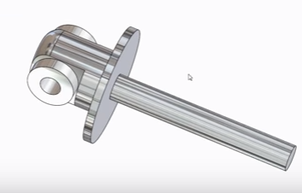

Individual Parts of the shock absorber.
fig.1 BASE

fig 2. TOP ROD

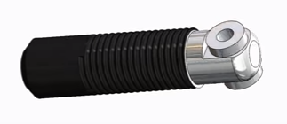

fig. 3 SPRING
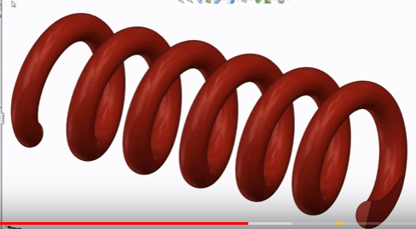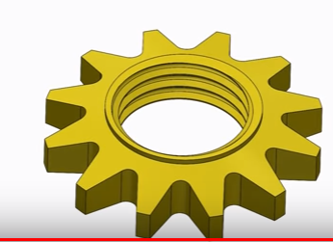
fig. 4 NUT
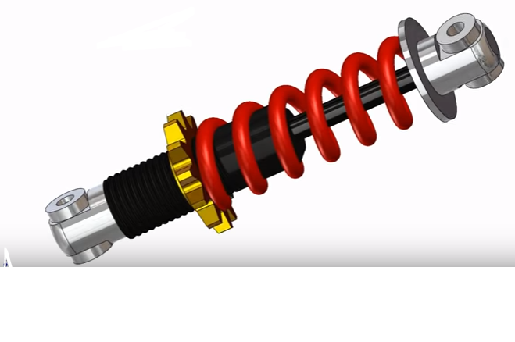
Fig. 5 Shock Absorber Final Assembly
Nut

A shock Absorber has 4 components, namely

- The Base
- It is made up of Polished Aluminium

- The Top Rod
- The Top Rod is made up of High Gloss Aluminium with a surface coating of Plastic. The length of the threads is upto 50mm with the pitch being 3 mm.

- The Spring
- The Spring is made up of Polished Steel, with a top coating of Medium Gloss Plastic. Its thickness is 7.25 mm, and it has 6 number of turns

- The Nut
- The Nut has 12 teeth and is tapered at an angle of 15 degrees. It is made up of Steel, with a top coating of Low Gloss Plastic

6. Failure under Stress

The model was designed as shown above in Solidworks and then imported into ANSYS Workbench for evaluation of stress and deflection of its various components. The “Assembly” file from DSS environment had to be first translated into a “PARA” file, which was then imported into the “ANSYS -Mechanical APDL” environment for further stress analysis.

Different materials will be tried for the spring so as to arrive at the best material for the same.

ANSYS is general-purpose finite element analysis (FEA) software package. Finite Element Analysis is a numerical method of deconstructing a complex system into very small pieces (of user-designated size) called elements. The software Implements equations that govern the behavior of these elements and solves them all; creating a comprehensive explanation of how the system acts as a whole.

These results then can be presented in tabulated or graphical forms. This type of analysis is typically used for the design and optimization of a system far too complex to analyze by hand.

Therefore, these assumptions and calculations were considered prior to the analysis of our suspension spring for two-wheelers.

7. Results & Inferences

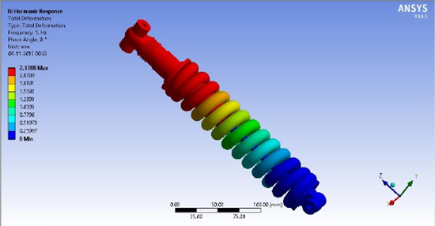

Until now, the analysis has been done on the conventional spring material, ie, stainless steel. The minimum deflection has been found out to be 1.9713 mm.

And the highest deflection has been found out to be 18.4931 mm.

8. Verification-Validation

The results of spring steel, beryllium copper, and carbon fibre will be
validated with help of previously done research on the same.
The values obtained using chromium-stainless steel, Monel and phosphor bronze will be compared with the values so as to arrive at the best material for spring manufacture.
The analysis results which will be further done by us will then be compared with the values from the previously published research work, as referenced from the Internet.

9. Conclusion

The various conclusions that we were able to make at the end of our project are summarised below:

The deflections due to each material Spring Steel were analysed using ANSYS Workbench and the results of Spring Steel were validated using existing results.

It has highest shock absorbing property due to minimum deflection of 1.9713 mm.

It has highest shock absorbing property due to highest deflection of 18.4931 mm.

In terms of shock absorbing property, Spring Steel is preferable because it has high wear and fatigue resistance and decent shock absorbing property.

It can be used for a large number of cycles without failure.

Although it possesses good corrosion resistance, it tends to have a low shock absorbing capacity.
10 .Further Scope

This paper therefore, concludes that further study of the factors influencing the choice of materials for use as the “spring-metal” shall be carried out.

Furthermore, the choice or selection of a reinforced structural design for the spring-damper system could help alleviate limits or extremities encompassing failure under high stress.

We aspire to develop such a solution to the aforementioned problem that could potentially cater to the modern day material engineering needs. The scope of the future study would be to add tests for stress failure analysis while changing the materials employed, from spring steel to viz. Phosphor Bronze,Monel, Carbon fiber, Beryllium Copper and Chromium-Steel.

The said improvisations and modifications ought to be thoroughly studied over the during the preparatory time, and shall be duly presented at the time of Review II on 25-10.2017.

Other recent developments pertaining to this project can be easily followed at http://14BME0133.github.io/MEE305/ until the next discussion.

11. References

1. http://wikipedia.org - “Helical Springs and Damping”

2. “Theory of Machines” authored by S.S.Ratan

3. smb://intranet.vit.ac.in - “//10.11.14.11/*” : Finite Element Methods for Engineers, UG and PG

4. http://autodesk.com - “CAmD cookbook”

5. “Design Data Book" published by PSGU Press, PSG University, Coimbatore.

6. VC and Releases: https://14BME0133.github.io/MEE305/

<#!eof>

